**Entry Test**

**Name: __________________________ Date: __________________**

**Class: ___________________________ Mark: _________________**

**1. Look, read and choose. (20 points)**

1 camera/mobile phone 2. tent/sleeping bag 3. skiing/skating

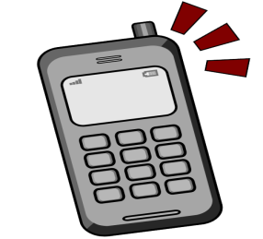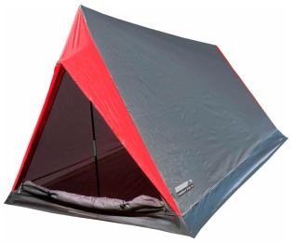

4.play the violin/guitar 5. station/garage 6. baker/nurse

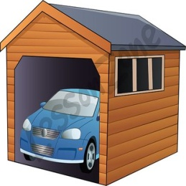

7. pineapple/mango 8. butter/flour 9. a carton of milk/

a loaf of bread

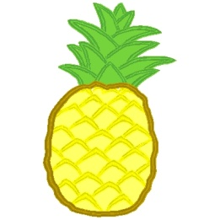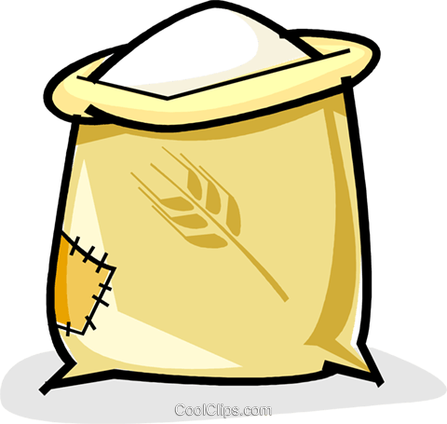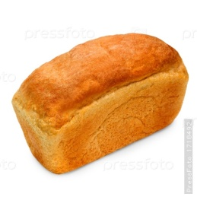

10. hippo/monkey

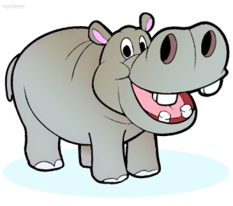

Points: ___

20

**2. Cross the odd one out. (20 points)**

1. whale, dolphin, lizard, seal

2. June, July, January, August

3. beans, lemons, apples, pineapples

4. tall, short, slim, hair

5. greengrocer, baker’s, waiter, mechanic

Points:___

20

**3. Read and choose. (20 points)**

1. The keys are …. the table.

A on B behind C next to

2. Do we need ….. oranges for the fruit salad?

A many B much C no

3. Whales are …… than dolphins.

A big B bigger C the biggest

4. You ….. wear a uniform at school.

A may B must C can

5. Larry and Lulu …… at the zoo yesterday.

A was B were C are

6. …. they watch a film last night?

A Did B Do C Does

7. Mary …… a sandwich now.

A eats B eating C is eating

8. Liza is the …… student in my class.

A good B better C best

9. I ….. going to visit my granny this Sunday.

A am B is C are

10. Alice ….. a letter last week.

A write B wrote C writes

Points: ____

20

**4. Read and choose. (20 marks)**

1. A: Goodbye, Philip.

B: a) Oh, hello!

b) Bye. See you later.

2. A: What does Harry look like?

B: a) He’s tall and slim with fair hair.

b) He’s very funny!

3. A: What do you do?

B: a) I’m a nurse. I help sick people.

b) I’m working now.

4. A: Can you pass me the sugar, please?

B: a) No, thanks!

b) Sure. Here you are!

5. A: What time is Jenny’s party?

B: a) At half past six.

b) Next week.

Points: ____

20

**5. Read the letter and write *yes* or *no*. (20 points).**

Dear Sarah,

How are you? Hope you’re fine!

My parents and I went to London last weekend. It was great! The weather was

warm and cloudy, but not rainy. We visited the Victoria and Albert Museum and

then we went shopping. In the evening we ate at an Italian restaurant. The next day,

we saw amazing wax models of famous people at Madame Tussauds and then

we walked to Buckingham Palace. I had a good time!

Write back soon,

Alice.

1. Alice and her family were in England last weekend. _______

2. The weather was rainy. _______

3. They visited the museum before going shopping. _______

4. They had dinner in a Russian restaurant. _______

5. They saw the Queen in Buckingham Palace. _______

Points: ____ My score: _____